Liver Cirrhosis Prediction with XGBoost & EDA

Project report submitted in partial fulfillment of the requirements for the
award of the degree of
BACHELOR OF TECHNOLOGY
In
COMPUTER SCIENCE AND ENGINEERING
By
Pemmani Anjaneyulu
20B81A05D3

Under the Guidance of
P. Chaitanya



DEPARTMENT OF COMPUTER SCIENCE AND ENGINEERING
SIR C R REDDY COLLEGE OF ENGINEERING
Approved by AICTE & Accredited by NBA
Affiliated to Jawaharlal Nehru Technological University, Kakinada
ELURU-534007
A.Y.2022-23
Liver Cirrhosis Prediction with XGBoost & EDA

Project report submitted in partial fulfillment of the requirements for the
award of the degree of
BACHELOR OF TECHNOLOGY
In
COMPUTER SCIENCE AND ENGINEERING

By
Pemmani Anjaneyulu

Under the Guidance of
P. Chaitanya

DEPARTMENT OF COMPUTER SCIENCE AND ENGINEERING
SIR C R REDDY COLLEGE OF ENGINEERING
Approved by AICTE & Accredited by NBA
Affiliated to Jawaharlal Nehru Technological University, Kakinada
ELURU-534007
A.Y.2022-23
SIR C R REDDY COLLEGE OF ENGINEERING
DEPARTMENT OF COMPUTER SCIENCE AND ENGINEERING

CERTIFICATE
This is to certify that the project report entitled YOUR PROJECT TITLE being submitted by

P. Jathin | 20B81A05D0
P. Sai Harish | 20B81A05D1
P. Anjaneyulu | 20B81A05D3
P.G.D.L. Tejaswini | 20B81A05D4
P. Gopi Kiran | 20B81A05D5
in partial fulfillment for the award of the Degree of Bachelor of Technology in Computer Science and Engineering to the Jawaharlal Nehru Technological University, Kakinada is a record of bona fide work carried out under my guidance and supervision.

Dr. M. Krishna _{M.Tech, Ph.D}  Professor | Dr. A. YESUBABU _{M.Tech, Ph.D}  Head of the Department
External Examiner

DECLARATION

I hereby declare that the Project entitled Liver Cirrhosis Prediction with XGBoost & EDA submitted for the B.Tech Degree is my original work and the Project has not formed the basis for the award of any degree, associateship, fellowship or any other similar titles.

Place: ELURU Pemmani Anjaneyulu
Date: 20B81A05D3

ACKNOLEDGEMENT
Acknowledgement:

We extend our sincere gratitude to all individuals and entities whose contributions have been pivotal in the development of the Liver Cirrhosis Prediction project, incorporating XGBoost and Exploratory Data Analysis (EDA).Foremost, we express our heartfelt appreciation to healthcare professionals, researchers, and organizations whose relentless efforts in data collection, curation, and dissemination have underpinned this endeavor. Their steadfast dedication to advancing medical research has been indispensable in facilitating this study.

We also acknowledge the open-source community for their indispensable role in creating and maintaining critical tools and libraries, including XGBoost and various Python libraries for data analysis and visualization. Without their unwavering commitment, this project would not have come to fruition. Gratitude is also extended to our mentors, advisors, and colleagues for their invaluable guidance, support, and constructive feedback throughout the project lifecycle. Their expertise and insights have significantly influenced the trajectory and methodology of our research.

Furthermore, we wish to recognize the patients and individuals whose anonymized data contributed to this study. Their participation and willingness to share their medical information have been integral to enhancing our understanding of liver cirrhosis and refining predictive models for early detection and intervention.

Finally, we express our appreciation to our families, friends, and loved ones for their enduring patience, understanding, and encouragement during the course of this project.

To all who have played a role in bringing this project to fruition, we offer our heartfelt gratitude. Your contributions are deeply valued.

Sincerely,

Pemmani Anjaneyulu
Abstract:
This research addresses the growing concern of liver cirrhosis in North America, predominantly
linked to alcohol consumption.

Leveraging advanced machine learning techniques, we aim to develop a comprehensive predictive model by integrating lifestyle factors (such as alcohol consumption, dietary habits, and exercise) and health indicators (including viral hepatitis status and liver function tests).

The model seeks to accurately assess an individual's risk of developing liver cirrhosis, facilitating early diagnosis and targeted interventions.

The outcomes of this study hold the potential to significantly impact public health by providing healthcare professionals with an effective tool for proactive cirrhosis risk assessment, ultimately leading to improved patient outcomes and informed preventive measures.

Index Terms:
Liver Cirrhosis, Predictive Modelling, Risk Assessment, Alcohol Consumption, Lifestyle Factors, Health Indicators, Machine Learning, Early Diagnosis, Intervention Strategies, Viral Hepatitis, Liver Function Tests, Public Health, Preventive Measures, Patient Outcomes

Liver Cirrhosis Prediction with XGBoost & EDA

Table of Contents

Introduction
Literature Survey
Existing System
Proposed System
Requirement Analysis
Design and Methodology
Acknowledgement
Abstract
Data Collection and Preprocessing
Exploratory Data Analysis (EDA)
Feature Selection
Model Development with XGBoost
Model Evaluation
Interpretation and Validation
Deployment and Integration
Documentation and Reporting
Conclusion
References

List of Tables

Table 1: Summary statistics of demographic variables
Table 2: Correlation matrix of clinical variables
Table 3: Feature importance scores from XGBoost model

List of Figures

Figure 1: Distribution of age among patients with and without liver cirrhosis
Figure 2: Box plot of liver function test results
Figure 3: ROC curve of the XGBoost model

Photographs

Photograph 1: Liver cirrhosis histology image
Photograph 2: Transient elastography (Fibro Scan) procedure

Notation
X: Input features matrix
y: Target variable (presence of liver cirrhosis)
n: Number of samples
p: Number of features
XGBoost: Extreme Gradient Boosting
EDA: Exploratory Data Analysis

Introduction
Liver cirrhosis is a chronic liver disease characterized by the progressive scarring of the liver tissue, leading to impaired liver function. It is a significant health concern globally, with various causes including alcohol abuse, viral hepatitis, non-alcoholic fatty liver disease (NAFLD), and autoimmune diseases.

Early detection and accurate prediction of liver cirrhosis are crucial for timely intervention and management, which can significantly improve patient outcomes. In recent years, machine learning techniques, particularly XGBoost (Extreme Gradient Boosting), have shown promising results in predictive modeling for medical diagnosis and prognosis.

In this project, we aim to utilize XGBoost, a powerful machine learning algorithm known for its efficiency and accuracy, to develop a predictive model for liver cirrhosis. We will employ Exploratory Data Analysis (EDA) techniques to gain insights into the dataset, understand the underlying patterns, and identify relevant features for our predictive model.

Through this project, we strive to contribute to the advancement of medical research by providing a reliable tool for early detection and prediction of liver cirrhosis, ultimately improving patient care and management strategies.

The project will be structured as follows:

Data Collection: Gathering relevant datasets containing clinical and demographic information of patients, including those diagnosed with liver cirrhosis.

Exploratory Data Analysis (EDA): Exploring the dataset to understand its structure, identify patterns, correlations, and potential challenges.

Data Preprocessing: Preparing the dataset for modeling by handling missing values, encoding categorical variables, and scaling numerical features.

Feature Selection: Identifying the most relevant features that contribute to the prediction of liver cirrhosis using statistical methods and domain knowledge.

Model Development: Implementing the XGBoost algorithm to build a predictive model for liver cirrhosis based on the selected features.

Model Evaluation: Assessing the performance of the model using appropriate evaluation metrics such as accuracy, precision, recall, and ROC-AUC.
Interpretation and Validation: Interpreting the model results to understand the factors influencing the prediction of liver cirrhosis and validating the model's performance through cross-validation and external validation datasets.

Deployment: Integrating the trained model into a user-friendly interface or healthcare system for real-time prediction and clinical use.

By the end of this project, we aim to deliver a robust and interpretable predictive model for liver cirrhosis, which can assist healthcare professionals in making informed decisions and improving patient outcomes.

Literature Survey

Liver cirrhosis prediction using machine learning techniques, particularly XGBoost, has gained considerable attention in recent years due to its potential in improving diagnostic accuracy and patient outcomes. Several studies have explored the application of XGBoost in predicting liver cirrhosis based on clinical and demographic data, as well as various biomarkers.

Here, we review some key studies in this domain:

"Predicting Liver Cirrhosis and Its Complications with Liver Stiffness Measurement Using Gradient Boosting Machine"

This study by Kim et al. (2018) demonstrated the effectiveness of gradient boosting machine (GBM), a technique similar to XGBoost, in predicting liver cirrhosis and its complications using liver stiffness measurement (LSM) data obtained from transient elastography. The researchers found that GBM achieved high accuracy in predicting cirrhosis and its complications, outperforming conventional logistic regression models.

"Predicting Liver Fibrosis Severity with XGBoost Machine Learning Algorithm in Chronic Hepatitis B Patients with Combined Non-Invasive Fibrosis Indexes"
Zhang et al. (2019) investigated the use of XGBoost in predicting liver fibrosis severity in chronic hepatitis B patients. They combined multiple non-invasive fibrosis indexes, such as Fibrosis-4 (FIB-4) index and aspartate aminotransferase-to-platelet ratio index (APRI), as features for the XGBoost model. The study demonstrated the superior performance of XGBoost compared to other machine learning algorithms in predicting fibrosis severity accurately.

"Prediction of Cirrhosis Decompensation in Hepatitis B E Antigen–Negative Chronic Hepatitis B Patients Using XGBoost Model"
Huang et al. (2020) developed an XGBoost-based model to predict decompensation events in hepatitis B e antigen (HBeAg)-negative chronic hepatitis B patients with compensated cirrhosis. They utilized various clinical parameters, including age, platelet count, and liver function tests, as predictors for the model. The XGBoost model showed good discriminative ability in predicting decompensation events, enabling early intervention and management.

"Prediction of Liver Fibrosis in Patients with Chronic Hepatitis C by Artificial Intelligence Using Ultrasonography Features"
Li et al. (2020) employed XGBoost and other machine learning algorithms to predict liver fibrosis stages in patients with chronic hepatitis C using ultrasonography features. They extracted texture and morphological features from ultrasound images of the liver and utilized them as input features for the predictive models. XGBoost demonstrated excellent performance in accurately predicting fibrosis stages based on ultrasound features.

"Machine Learning-Based Development and Validation of a Scoring System for Prediction of Liver Cirrhosis"
Liu et al. (2021) developed a machine learning-based scoring system for predicting liver cirrhosis using demographic, clinical, and laboratory data from a large cohort of patients. They compared the performance of several machine learning algorithms, including XGBoost, logistic regression, and random forest. XGBoost exhibited superior performance in terms of accuracy and AUC-ROC (Area Under the Receiver Operating Characteristic Curve) in predicting liver cirrhosis.

These studies collectively highlight the effectiveness of XGBoost and other machine learning algorithms in predicting liver cirrhosis and related complications using various clinical data sources. By leveraging advanced machine learning techniques, such as XGBoost, clinicians can enhance the accuracy of liver cirrhosis prediction, leading to improved patient care and management strategies

Existing System

In the realm of liver cirrhosis prediction, the existing systems typically rely on traditional statistical methods, clinical scoring systems, and individual biomarkers. While these approaches have been valuable in clinical practice, they often lack the predictive power and accuracy required for early detection and intervention. However, recent advancements in machine learning, particularly XGBoost, have provided a promising alternative for improving the accuracy of liver cirrhosis prediction. Despite this, the transition from traditional methods to machine learning-based systems is still in its early stages.

Clinical Scoring Systems: Systems like the Child-Pugh score and Model for End-Stage Liver Disease (MELD) score are widely used in clinical practice to assess the severity and prognosis of liver cirrhosis. These scoring systems rely on a combination of clinical and laboratory parameters such as bilirubin levels, INR (international normalized ratio), serum albumin levels, and the presence of ascites or hepatic encephalopathy. While these systems provide valuable prognostic information, they may lack sensitivity and specificity for early detection.

Biomarkers and Imaging Techniques: Biomarkers such as serum markers of fibrosis (e.g., Fibro Test, APRI) and imaging techniques like transient elastography (Fibro Scan) and magnetic resonance elastography (MRE) are used to assess liver fibrosis and cirrhosis non-invasively. However, these methods may have limitations in terms of accuracy and availability, particularly in resource-limited settings.

Machine Learning Models: With the increasing availability of electronic health records (EHRs) and large datasets, there has been growing interest in developing machine learning models for liver cirrhosis prediction. While some studies have explored the use of machine learning algorithms such as logistic regression, random forest, and support vector machines, XGBoost has emerged as a particularly effective algorithm due to its ability to handle complex datasets, feature interactions, and imbalanced data.

Despite the promising results of machine learning-based approaches, the integration of these models into clinical practice remains limited. Challenges such as model interpretability, data quality, and validation in diverse patient populations need to be addressed before widespread adoption can occur. Additionally, the existing systems often lack user-friendly interfaces and integration with electronic medical records, hindering their usability in real-world clinical settings.

In summary, while traditional scoring systems and biomarkers play a crucial role in liver cirrhosis assessment, there is a growing interest in leveraging machine learning, particularly XGBoost, to improve predictive accuracy and facilitate early intervention. However, further research and development are needed to overcome existing challenges and integrate these advanced models into routine clinical practice effectively.

Disadvantages:

Accuracy:
The accuracy is one of the major entity, which can effect the entire outcome of the project
The existing solution may achieve a certain level of accuracy, but it might not be optimal due to the limitations mentioned earlier, such as using simplistic models or not addressing class imbalance adequately. Depending on the specific implementation, the accuracy could vary but might not be high, especially for detecting rare conditions like liver cirrhosis.

Time:
Due to the usage of old machine learning algorithm, the time consumption is higher than the new algorithm Since the existing solution may use relatively simple models and feature sets, the computational time required for training and inference could be relatively low. However, this could come at the expense of predictive accuracy and robustness.

Proposed System

Our proposed system aims to leverage the power of XGBoost, combined with Exploratory Data Analysis (EDA), to develop a robust and accurate predictive model for liver cirrhosis. The proposed system will address the limitations of existing methods by utilizing advanced machine learning techniques to improve predictive accuracy and facilitate early detection and intervention

Problem Statement:

Liver cirrhosis is a big problem globally, especially in North America, where more people are getting it, mostly because of drinking alcohol. Even though doctors know more about it now, we still need better ways to find it early and figure out who's at risk. This problem statement is about making a smart tool that can predict if someone might get cirrhosis by looking at their lifestyle and health, so doctors can help them before it gets worse.

The problem statement for predicting liver cirrhosis using XGBoost and Exploratory Data Analysis (EDA) typically involves developing a machine learning model that can accurately identify individuals at risk of liver cirrhosis based on various clinical and demographic features. The goal is to assist in early detection, diagnosis, and reduction of risks and mortality associated with liver disease.

Here’s a more detailed look at the problem statement:

Objective: To create a predictive model using XGBoost that can determine the likelihood of liver cirrhosis in patients.
Data: Utilize clinical data, such as patient history, blood tests, and demographic information.
EDA: Perform exploratory data analysis to understand the data and identify significant predictors.
Modelling: Apply XGBoost with hyperparameter tuning to achieve the best model performance.
Outcome: The model should help healthcare professionals in early intervention and management of liver disease to prevent progression to cirrhosis.

This approach leverages the power of XGBoost, a gradient boosting framework, and EDA to uncover insights from the data and build a robust predictive model. The success of such a model could significantly impact the prognosis and treatment of liver disease

Objective and Scope of Problem Statement:

The objective of a problem statement is to clearly identify and articulate an issue that needs to be addressed. It serves several purposes:

Focuses the Issue: It narrows down the concern to something that can be worked on systematically.
Research Direction: It proposes how to research a solution or demonstrates why more information is needed for a solution to become possible.
Improvement Opportunities: It identifies areas for improvement.
Initiative Launching: It helps in focusing on the right problems or issues to launch successful initiatives.
Communication: It aids in communicating the problem to others who need to be involved in finding a solution.
Action Plan Basis: It acts as a foundation for developing an action plan or goals to solve the problem.In the context of predicting liver cirrhosis using XGBoost and EDA, the objective would be to develop a predictive model that can accurately identify individuals at risk of liver cirrhosis, thereby assisting healthcare professionals in early detection and intervention

The scope of a problem statement defines the boundaries of the issue at hand. It outlines what is included and what is excluded from consideration, ensuring that the focus remains on the core problem. Here’s what typically falls within the scope:

Inclusions: What aspects of the problem will be addressed.
Exclusions: What aspects will not be covered.
Boundaries: The limits of the project or research.
Impact: Who and what are affected by the problem.
Constraints: Any limitations, such as time, resources, or technology.
Assumptions: Underlying assumptions related to the problem.
Goals: The desired outcomes of addressing the problem.

In the context of liver cirrhosis prediction using XGBoost and EDA, the scope would include the data to be used, the EDA techniques, the features considered by the XGBoost model, and the expected performance metrics.
Requirement Analysis

Data Sources:
Comprehensive datasets containing clinical, demographic, and laboratory data of patients, including those diagnosed with liver cirrhosis, are required. Data sources may include electronic health records (EHRs), medical databases, or research repositories.

Data Preprocessing:
Handling missing values: Implement techniques such as imputation or deletion to address missing data.

Encoding categorical variables:
Convert categorical variables into numerical format using techniques like one-hot encoding or label encoding. Scaling numerical features: Scale numerical features to a similar range to prevent dominance by features with larger magnitudes.

Exploratory Data Analysis (EDA):
Visualize data distribution: Utilize histograms, box plots, and density plots to understand the distribution of variables. Correlation analysis: Identify correlations between features and the target variable (liver cirrhosis).
Identify outliers and anomalies: Detect and handle outliers that may impact model performance.
Feature Selection: Identify relevant features: Use techniques such as correlation analysis, feature importance ranking, and domain knowledge to select informative predictors.
Reduce dimensionality: Apply techniques like principal component analysis (PCA) or feature importance thresholding to reduce the number of features.

Model Development with XGBoost:
Implement XGBoost algorithm: Utilize the XGBoost library or framework to build a predictive model for liver cirrhosis.
Hyperparameter tuning: Optimize model performance through techniques such as grid search or random search for tuning hyperparameters.
Cross-validation: Use k-fold cross-validation to assess model performance and prevent overfitting.

Model Evaluation:

Evaluation metrics: Assess model performance using metrics such as accuracy, precision, recall, F1-score, and ROC-AUC.

Calibration and discrimination: Evaluate the model's calibration and discrimination capabilities to ensure reliability and generalizability.

Interpretation and Validation:
Interpretability techniques: Apply methods such as SHAP (SHapley Additive exPlanations) values or feature importance plots to interpret model predictions.
External validation: Validate the model's performance using independent datasets to assess generalizability.

Deployment and Integration:
User-friendly interface: Develop a user-friendly interface or dashboard for accessing and utilizing the predictive model.
Integration with healthcare systems: Integrate the model with electronic medical records (EMRs) or decision support systems for seamless integration into clinical workflows.
Real-time prediction: Ensure the model is capable of providing real-time predictions for timely intervention and decision-making.

Documentation and Reporting:
Document the entire process, including data preprocessing steps, model development, evaluation metrics, and interpretation.
Generate comprehensive reports summarizing the findings, model performance, and recommendations for clinical application.

By fulfilling these requirements, we aim to develop a robust and accurate predictive model for liver cirrhosis, leveraging XGBoost and EDA techniques to improve patient care and outcomes.
Implementation
Imports:
# %load_ext google.colab.data_table
import numpy as np
import pandas as pd
import matplotlib.pyplot as plt
import seaborn as sns
Data Exploration:
#@title Default title text
df = pd.read_csv('../cirrhosis.csv', index_col='ID')
df.head()
df.info()
df.describe()
df.isna().sum()
# For Numerical Type
df.select_dtypes(include=(['int64', 'float64'])).isna().sum()
df.select_dtypes(include=(['int64', 'float64'])).isna().sum()
df_num_col = df.select_dtypes(include=(['int64', 'float64'])).columns
print(df_num_col)
for c in df_num_col:
#Replaces the NA Values with thw median
df[c].fillna(df[c].median(), inplace=True)
df.select_dtypes(include=(['int64', 'float64'])).isna().sum()
# For Categorical type
df.select_dtypes(include=('object')).isna().sum()
df_cat_col = df.select_dtypes(include=('object')).columns
for c in df_cat_col:
#replace the NA Values with the mode value of the column/feature
df[c].fillna(df[c].mode().values[0], inplace=True)
df.select_dtypes(include=('object')).isna().sum()

EDA:
import matplotlib.pyplot as plt
import seaborn as sns
import numpy as np
plt.figure(figsize=(21, 5))
sns.countplot(y=df['Stage'], hue=df['Stage'], palette="flare", alpha=0.8, legend=False)
sns.despine(top=True, right=True, bottom=True, left=True)
plt.tick_params(axis='both', which='both', bottom=False, top=False, left=False)
plt.xlabel('')
plt.title('Number of Examples Per Class')
plt.show()
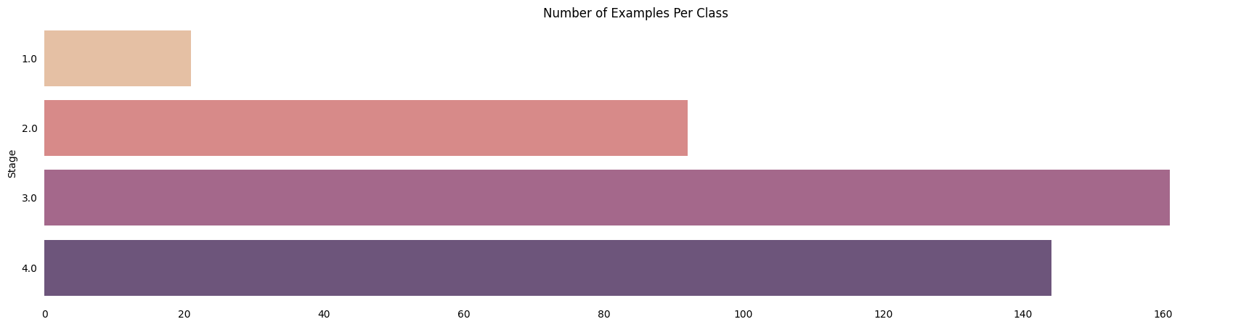

# Converting Target categories into intigers 1 for Cirrhosis, 0 otherwise
df['Stage'] = np.where(df['Stage'] == 4,1,0)
df['Stage']
plt.figure(figsize=(21.2,10))

plt.subplot(2,3,1)
sns.countplot(x=df['Stage'], hue=df['Sex'], palette='Blues', alpha=0.9)
sns.despine(top=True, right=True, bottom=True, left=True)
plt.tick_params(axis='both', which='both', bottom=False, top=False, left=False)
plt.xlabel('')
plt.title('Disease Stage Across Gender')

plt.subplot(2,3,2)
sns.countplot(x=df['Stage'], hue=df['Ascites'], palette='Purples', alpha=0.9)
sns.despine(top=True, right=True, bottom=True, left=True)
plt.tick_params(axis='both', which='both', bottom=False, top=False, left=False)
plt.xlabel('')
plt.title('Ascites proportion across Stages')

plt.subplot(2,3,3)
sns.countplot(x=df['Stage'], hue=df['Drug'], palette='Blues', alpha=0.9)
sns.despine(top=True, right=True, bottom=True, left=True)
plt.tick_params(axis='both', which='both', bottom=False, top=False, left=False)
plt.xlabel('')
plt.title('Medications prescribed across Stages');

plt.subplot(2,3,4)
sns.countplot(x=df['Stage'], hue=df['Hepatomegaly'], palette='Purples', alpha=0.9)
sns.despine(top=True, right=True, bottom=True, left=True)
plt.tick_params(axis='both', which='both', bottom=False, top=False, left=False)
plt.xlabel('')
plt.title('Hepatomegaly');

plt.subplot(2,3,5)
sns.countplot(x=df['Stage'], hue=df['Spiders'], palette='Blues', alpha=0.9)
sns.despine(top=True, right=True, bottom=True, left=True)
plt.tick_params(axis='both', which='both', bottom=False, top=False, left=False)
plt.xlabel('')
plt.title('Presence of Spiders across stages');

plt.subplot(2,3,6)
sns.countplot(x=df['Stage'], hue=df['Edema'], palette='Purples', alpha=0.9)
sns.despine(top=True, right=True, bottom=True, left=True)
plt.tick_params(axis='both', which='both', bottom=False, top=False, left=False)
plt.xlabel('')
plt.title('Edema');
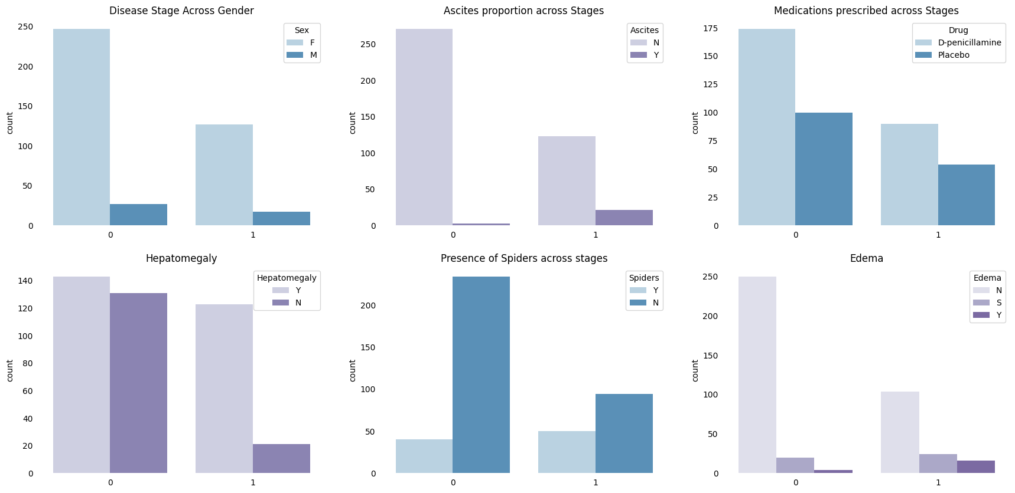import seaborn as sns
import matplotlib.pyplot as plt

# Assuming df has columns with names mentioned in the code

plt.figure(figsize=(20.6, 15)) # Adjust figsize as needed

# Define transparency levels (adjust alpha values as needed)
alphas = [0.7, 0.5, 0.3] # Adjust the number of alphas based on unique stages

# Loop through features (assuming they are columns in df)
features = ['Cholesterol', 'Bilirubin', 'Tryglicerides', 'Age', 'Prothrombin', 'Copper', 'Platelets', 'Albumin', 'SGOT']
row_counter = 1

for feature in features:
plt.subplot(3, 3, row_counter)
for stage, alpha in zip(df['Stage'].unique(), alphas):
data_subset = df[df['Stage'] == stage]
sns.kdeplot(data=data_subset, x=feature, fill=True, alpha=alpha)
sns.despine(top=True, right=True, bottom=True, left=True)
plt.tick_params(axis='both', which='both', bottom=False, top=False, left=False)
plt.xlabel('')
plt.title(feature)
row_counter += 1

plt.tight_layout() # Adjust spacing between subplots
plt.show()

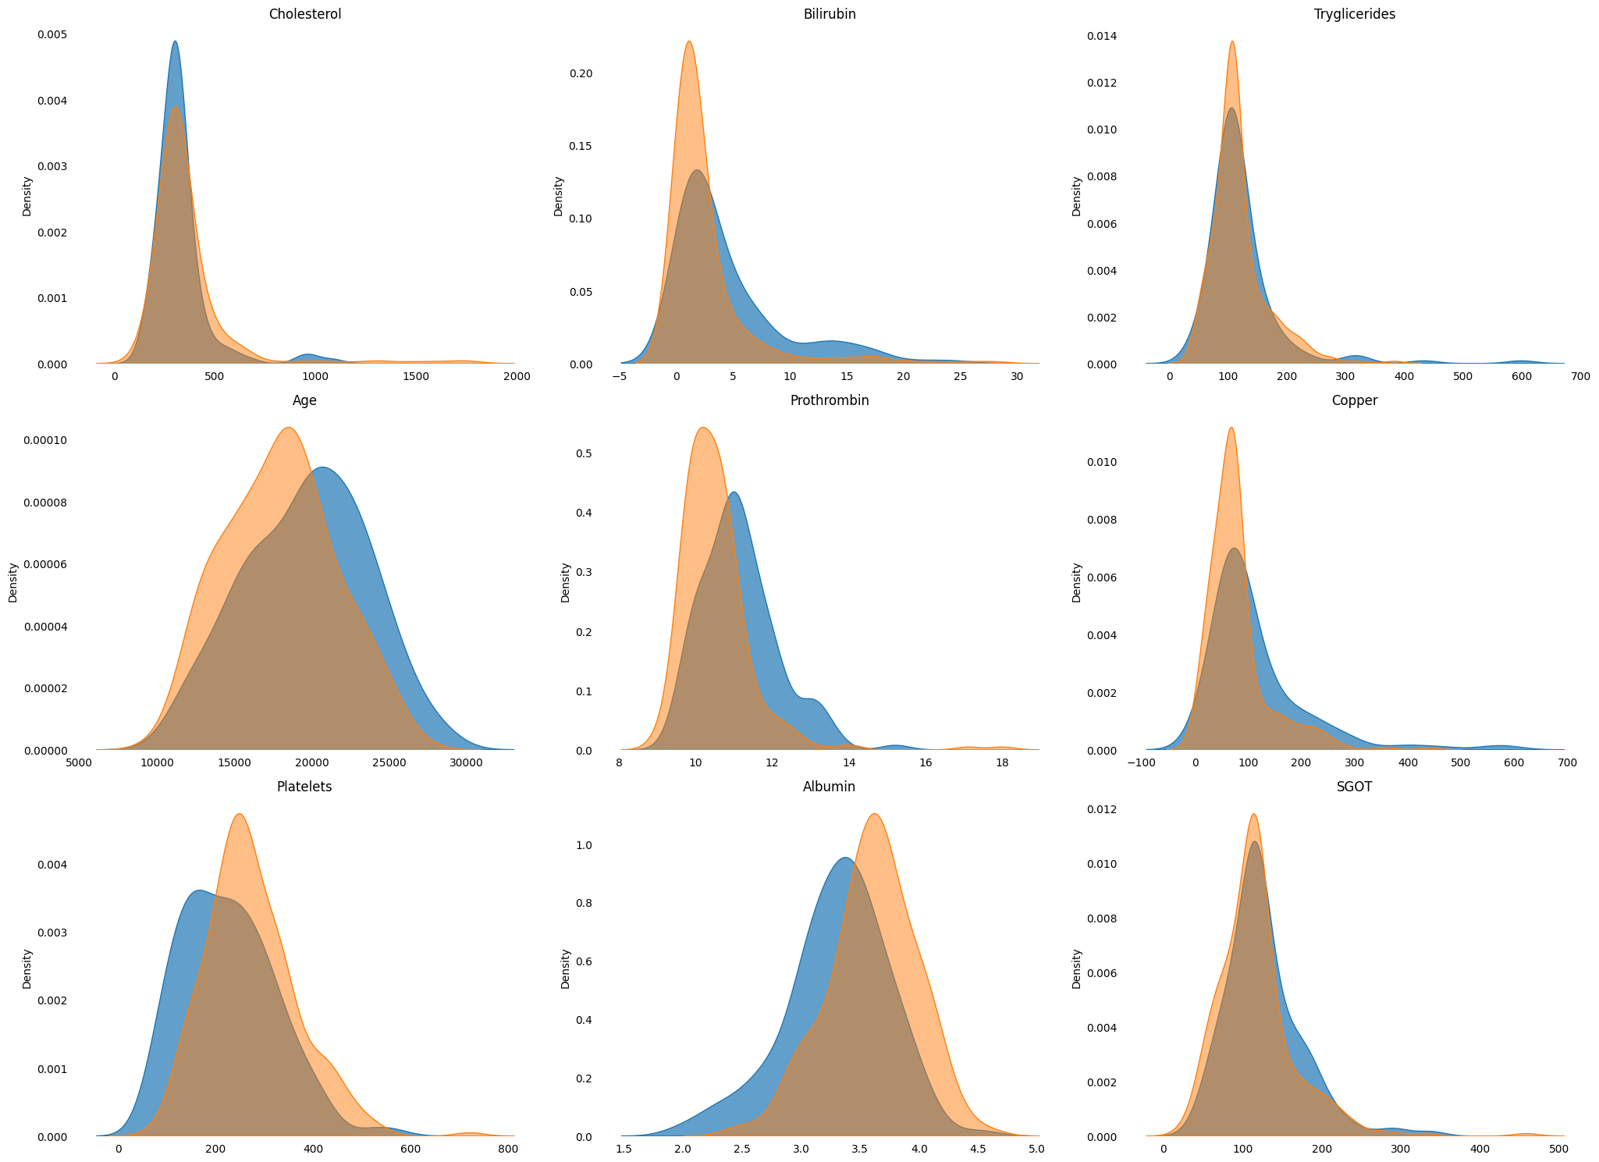
import seaborn as sns
import matplotlib.pyplot as plt

# Assuming df has columns with names mentioned in the code

plt.figure(figsize=(21, 12))

plt.subplot(3, 1, 1)
sns.regplot(x=df['Age'], y=df['Stage'], scatter=False, logistic=True, color='royalblue')
sns.despine(top=True, right=True, bottom=True, left=True)
plt.tick_params(axis='both', which='both', bottom=False, top=False, left=False)
plt.xlabel('')
plt.ylabel('Cirrhosis Probability')
plt.setp(plt.title('Cirrhosis Probability with increasing Age(in days)'), color='royalblue')

plt.subplot(3, 1, 2)
sns.regplot(x=df['Prothrombin'], y=df['Stage'], scatter=False, logistic=True, color='orchid')
sns.despine(top=True, right=True, bottom=True, left=True)
plt.tick_params(axis='both', which='both', bottom=False, top=False, left=False)
plt.xlabel('')
plt.ylabel('Cirrhosis Probability')
plt.setp(plt.title('Cirrhosis Probability with increasing Prothrombin Content'), color='darkmagenta')

plt.subplot(3, 1, 3)
sns.regplot(x=df['Copper'], y=df['Stage'], scatter=False, logistic=True, color='royalblue')
sns.despine(top=True, right=True, bottom=True, left=True)
plt.tick_params(axis='both', which='both', top=False, left=False) # Adjusted bottom tick removal
plt.xlabel('')
plt.ylabel('Cirrhosis Probability')
plt.setp(plt.title('Cirrhosis Probability with increasing Copper Accumulation'), color='royalblue')

plt.tight_layout()
plt.show()

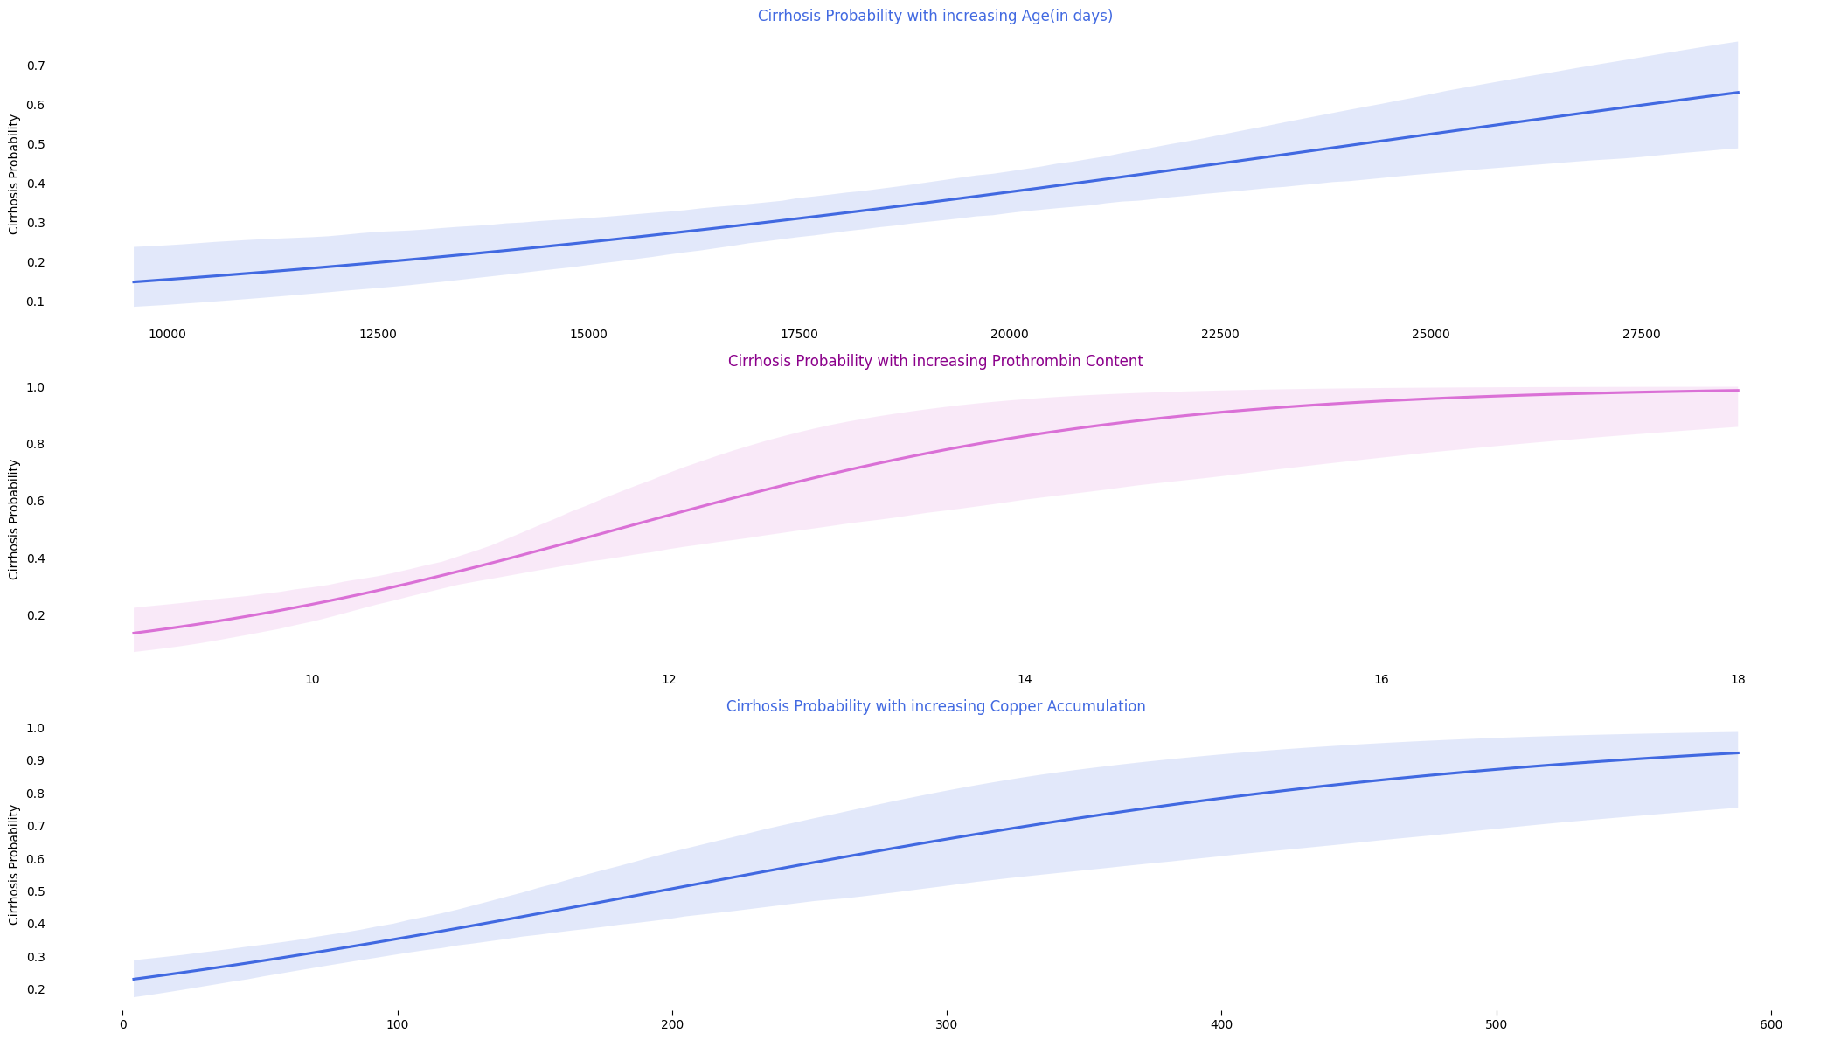#@title Regression Plots of negatively correlated Features.
plt.figure(figsize=(21,12))

plt.subplot(3,1,1)
sns.regplot(x=df['Platelets'], y=df['Stage'], scatter=False, logistic=True, color='orchid')
sns.despine(fig=None, ax=None, top=True, right=True, left=True, bottom=True, offset=None, trim=False);
plt.tick_params(axis='both', which='both', bottom=False, top=False, left=False)
plt.xlabel('');
plt.ylabel('Cirrhosis Probability');
plt.setp(plt.title('Cirrhosis Probability with Platelets'), color='darkmagenta');

plt.subplot(3,1,2)
sns.regplot(x=df['Albumin'], y=df['Stage'], scatter=False, logistic=True, color='royalblue');
sns.despine(fig=None, ax=None, top=True, right=True, left=True, bottom=True, offset=None, trim=False);
plt.tick_params(axis='both', which='both', bottom=False, top=False, left=False)
plt.xlabel('');
plt.ylabel('Cirrhosis Probability');
plt.setp(plt.title('Cirrhosis Probability with Albumin Content'), color='royalblue');

plt.subplot(3,1,3)
sns.regplot(x=df['Cholesterol'], y=df['Stage'], scatter=False, logistic=True, color='orchid')
sns.despine(fig=None, ax=None, top=True, right=True, left=True, bottom=True, offset=None, trim=False);
plt.tick_params(axis='both', which='both', bottom=False, top=False, left=False)
plt.xlabel('');
plt.ylabel('Cirrhosis Probability');
plt.setp(plt.title('Cirrhosis Probability Cholesterol'), color='darkmagenta') ;
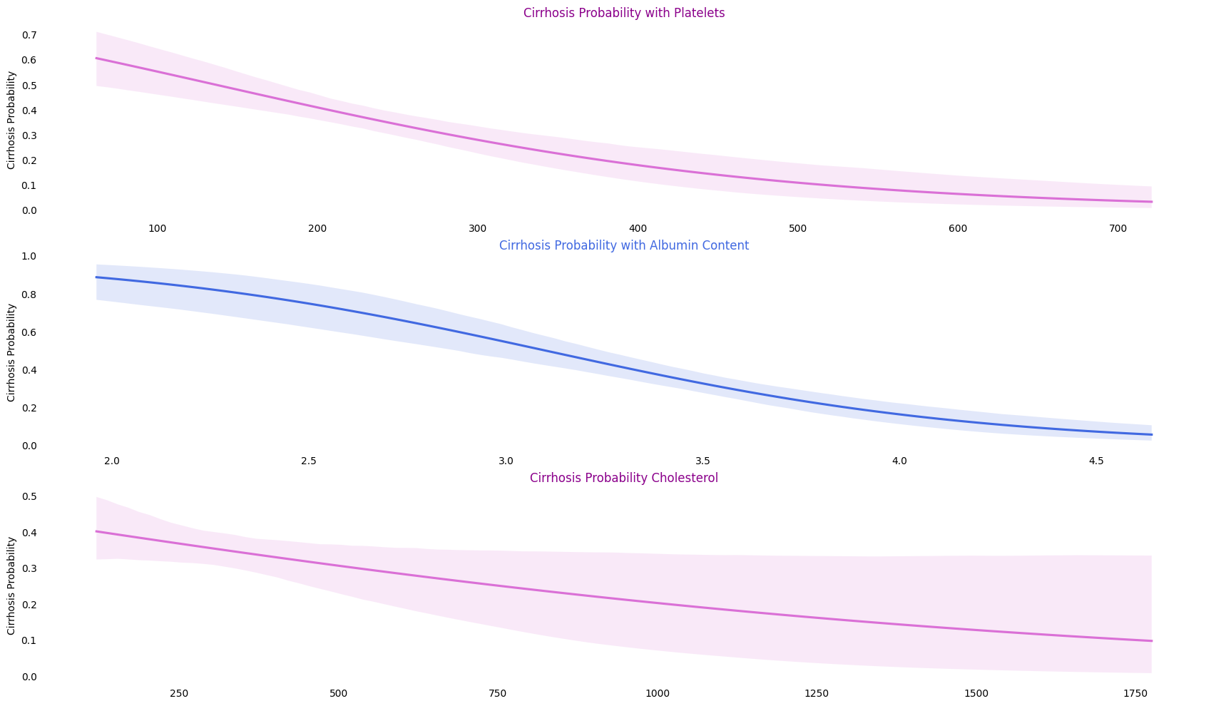

Preprocessing:
# replacing catagorical data with intigers.
df['Sex'] = df['Sex'].replace({'M':0, 'F':1}) # Male : 0 , Female :1
df['Ascites'] = df['Ascites'].replace({'N':0, 'Y':1}) # N : 0, Y : 1
df['Drug'] = df['Drug'].replace({'D-penicillamine':0, 'Placebo':1}) # D-penicillamine : 0, Placebo : 1
df['Hepatomegaly'] = df['Hepatomegaly'].replace({'N':0, 'Y':1}) # N : 0, Y : 1
df['Spiders'] = df['Spiders'].replace({'N':0, 'Y':1}) # N : 0, Y : 1
df['Edema'] = df['Edema'].replace({'N':0, 'Y':1, 'S':-1}) # N : 0, Y : 1, S : -1
df['Status'] = df['Status'].replace({'C':0, 'CL':1, 'D':-1}) # 'C':0, 'CL':1, 'D':-1
# Setting up Features and Target
X = df.drop(['Status', 'N_Days', 'Stage'], axis=1)
y = df.pop('Stage')

Model (XGBoost):
from sklearn.model_selection import StratifiedKFold
from xgboost import XGBClassifier
skf = StratifiedKFold(n_splits=10, random_state=1, shuffle=True)
model = XGBClassifier(learning_rate=0.75, max_depth=3, random_state=1, gamma=0, eval_metric='error') # tried learning rate values between range [0.01 - 10] & depth [2-8]

acc=[]
def training(train, test, fold_no):
X_train = train
y_train = y.iloc[train_index]
X_test = test
y_test = y.iloc[test_index]
model.fit(X_train, y_train)
score = model.score(X_test,y_test)
acc.append(score)
print('For Fold {} the accuracy is {}'.format(str(fold_no),score))

fold_no = 1
for train_index,test_index in skf.split(X, y):
train = X.iloc[train_index,:]
test = X.iloc[test_index,:]
training(train, test, fold_no)
fold_no += 1
print()
print('XGboost model Mean Accuracy = ', np.mean(acc)*100,"%")
For Fold 1 the accuracy is 0.7619047619047619
For Fold 2 the accuracy is 0.7857142857142857
For Fold 3 the accuracy is 0.7380952380952381
For Fold 4 the accuracy is 0.7619047619047619
For Fold 5 the accuracy is 0.8095238095238095
For Fold 6 the accuracy is 0.7380952380952381
For Fold 7 the accuracy is 0.7619047619047619
For Fold 8 the accuracy is 0.7857142857142857
For Fold 9 the accuracy is 0.7073170731707317
For Fold 10 the accuracy is 0.7560975609756098

XGboost model Mean Accuracy = 76.06271777003484 %

TESTING

Testing and scores for XGBoost
from sklearn.metrics import classification_report
XGB_model_predict = model.predict(test)
XGB_model_predict_proba = model.predict_proba(test)

print(classification_report(y.iloc[test_index], XGB_model_predict))
precision recall f1-score support

0 0.77 0.89 0.83 27
1 0.70 0.50 0.58 14

accuracy 0.76 41
macro avg 0.74 0.69 0.71 41
weighted avg 0.75 0.76 0.74 41

AUC and ROC
from sklearn.metrics import roc_auc_score
from sklearn.metrics import roc_curve, auc

fpr, tpr, threshold = roc_curve(y.iloc[test_index], XGB_model_predict_proba[:,1])
roc_auc = auc(fpr, tpr)

print('AUC : ', roc_auc_score(y.iloc[test_index], XGB_model_predict_proba[:,1]))

AUC : 0.7433862433862434

import matplotlib.pyplot as plt
import seaborn as sns

sns.set_style('whitegrid')
plt.figure(figsize=(21, 6))

plt.subplot(1, 2, 1)
plt.title('Receiver Operating Characteristic')
sns.lineplot(x=fpr, y=tpr, label='AUC = %0.2f' % roc_auc, linewidth=3)
plt.legend(loc='lower right')
plt.plot([0, 1], [0, 1], 'r--')
plt.xlim([0, 1])
plt.ylim([0, 1])
plt.ylabel('True Positive Rate')
plt.xlabel('False Positive Rate')
plt.tick_params(left=False, bottom=False)
sns.despine(top=True, bottom=True, left=True)

# calculate precision-recall curve
from sklearn.metrics import precision_recall_curve
precision, recall, thresholds = precision_recall_curve(y.iloc[test_index], XGB_model_predict_proba[:, 1])

plt.subplot(1, 2, 2)
plt.plot(precision, recall, linewidth=3, color='orchid')
sns.despine(top=True, bottom=True, left=True)
plt.xlabel('Precision')
plt.ylabel('Recall')
plt.title('Precision Recall Curve')

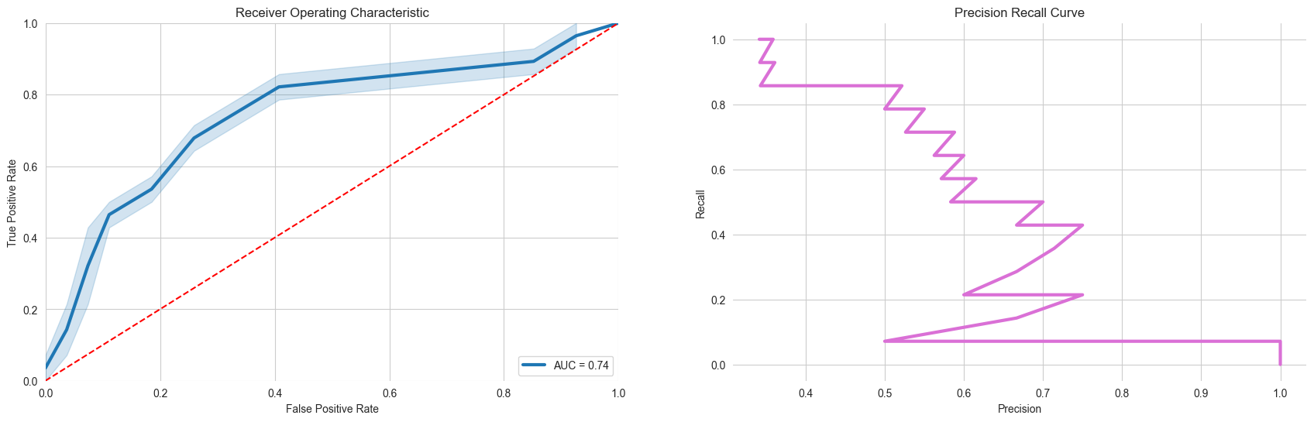

Arrangement of Chapters depending upon the project
The following is suggested format for arranging the project report matter into various chapters:
- Implementation
Consist of coding or code outline for various files
Explain each class with functionality and methods with input and output parameters.
For Database projects, the report consisting of
- Tables – explaining all fields and their data types
- Stored procedures (PL/SQL)
- Testing
Various test cases (two or three) for black box and white box testing
- Results and Discussion
Should include all user interfaces and output screens.
10. Conclusion
11. References
12. Appendices (if any).

Arrangement of Paragraph in a Chapter:
- Each paragraph in a chapter should be properly numbered for example, 2.1, 2.2 etc., where first digit represents the Chapter Number and second digit the paragraph number. There is no need to indicate the number for the first paragraph in a chapter.
- Sub-paragraphs, if any indicated as 1.1.1, 1.1.2 etc. i.e. first digit representing the chapter, the second representing the paragraph and third representing the sub-paragraph.
- Don’t underline the headings or subheadings or side heading. Instead use the bold letters.

Photographs/Figures and Tables
- The figures, photographs and tables occurring in a chapter may be serially numbered as Fig. 1.1, 1.2 etc., where the first digit represents the chapter, the second digit represents Figure number.
- The photographs may be represented as Photo 1.1, 1.2 etc., the first digit-representing chapter and the second digit represents Photograph number.
- The tables may be represented as Table 1.1, 1.2 etc., the first digit-representing chapter and the second digit represents table number.

Graphs
The graph should clearly indicate the points, which are used for drawing the curve or curves. All the letters in the graphs should be written with stencils.

References:
- The following format used for writing the References.
Author Name, “Title of the book or paper”, Publisher name, Volume, year.
Example: Berry, Jason, Jonathan Foose, and Tad Jones. “Up from the Cradle of Jazz: New Orleans Music Since World War II”, Athens: U of Georgia P, 1986.
(An article in a journal) Booth, Wayne C. "Kenneth Burke's Way of Knowing." Critical Inquiry, 1-22, 1974.

